**Embrace Dental Firm Proposal**

**Introduction**

Adjutech Company is pleased to submit this proposal to Embrace Dental hospital for the development of dental system. We welcome the opportunity to work with Embrace Dental Firm on this exciting project.

It is our understanding that Embrace Dental Firm seeks to design and develop its system to improve the organization and presentation of the content provided so that both patients, doctors, accountants and inventory managers can quickly access desired hospital services.

Adjutech Company believes we are highly qualified to assist and guide Embrace Dental Firm through a comprehensive system overhaul. Thus we combines strategic thinking and emerging technologies to provide innovative solutions that consistently break new ground.

Since the company’s birth, we have developed system for various clients and continuing to develop even better system since we believe that the world need to be digitized and us as Adjutech Company wants to be in the center and help companies , individuals and organizations achieve this , as it will improve either a companies, individual or organization’s efficiency.

We deliver high-quality work through our focus on bidirectional communication, responsive customer service, client education, accurate project management, product quality, and an ethical approach to business.

We have a well documented track record of performing work on budget and on deadline. We respectfully submit the following proposal, which includes information about our capabilities, methodology, example projects and other pertinent information for consideration.

Likimani is the designated point-of-contact for all communications regarding this proposal. He can be reached at +254 700 767290

**Approach and Methodology**

We approach each project as a true collaboration in ideation --the process of creating new Ideas. We offer our expertise and guidance whenever needed to ensure that the entire process is as smooth and enjoyable as possible. Adjutech Company’s commitment to quality is with you from concept through to post-implementation support so you can sleep well both during and after the development process.

We believe the ideation process begins the moment we connect with our clients. Our goal is to provide strategies and solutions that go beyond the expected. To make sure we deliver, we embrace the ideation process. Through this process listen hard to our customer's goals (and then listen again).

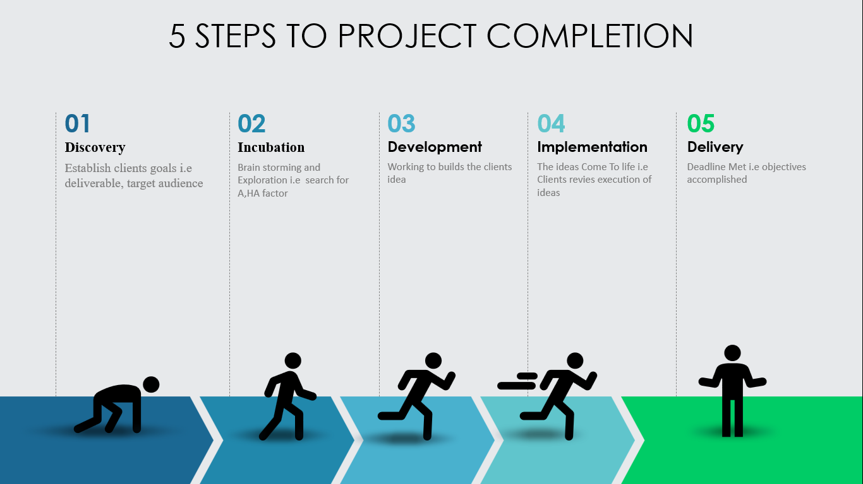

**Management Approach**

We approach each client engagement using a documented set of policies, processes, and procedures. Each client is assigned a project manager who acts as the primary point of contact for your organization. This project manager guides the project team through the development process to ensure timely and high-quality completion. The Adjutech Company team uses a comprehensive set of checklists, tasks and procedures that are tailored to each client. Our approach also includes co-location of all team members to encourage collaboration. In addition, daily project status meeting are held that focus on answering three questions: (a) “What have you done since yesterday?”; (b) “What are you planning to do today?”; and (c) “Do you have any problems preventing you from accomplishing your goal?”. This transparency and daily review of progress mitigates risk and ensures that close management of the project occurs at every stage. Behind the scenes the project manager coordinates with the executive team to ensure service quality.

**Development Process**

Adjutech Company will guide Embrace Dental hospital through the following discovery, planning, design and production process. Adhering to this process will ensure a successful outcome. Our process starts with Phase 0. Adjutech Company’s goal in this analytical phase is to define features concretely, determine technology integration specifics, and prioritize features so that investment is made in those areas that will provide the greatest return on investment for Embrace Dental hospital.

* Phase 0
* Strategic Analysis and Planning
* Information Architecture
* Wireframes
* Technical System Design
* Phase 1
* Graphical and User Interface Design
* Content Creation
* Implementation
* Testing
* Training and documentation
* Launching
* Post Launch and Maintenance

In the sections below we discuss the different portions of this process.